**Introduction**

Recommender systems are found everywhere and have become an essential component in helping companies guid their users throughout their products. As discussed throughout our summary, this project aims to compare different recommender system constructions and algorithms on the MovieLens dataset. At a very high level, there are two ways we hope to tackle this project. The first approach is to solely rely on previous users’ ratings and combine them in some sort of way to predict all other ratings, and the second approach is to incorporate user metadata such as user occupation and age.

As previously discussed, one of the biggest obstacles we expect to face is the matrix sparsity. As shown in table 1, our dataset (1M Movielens) has a density of 4.26%.

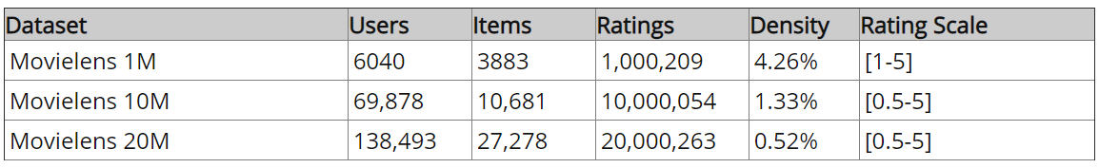

Table 1: Dataset Overview [1]

**Correlation**

**Matrix Factorization using Single Value Decomposition (SVD)**

One of the main things to consider when building this dataset is that although the matrices involved in recommender systems are extremely large, their rank is usually relatively small. It is for this reason that many people suggest the implementation of matrix factorization and reconstruction on such problems.

As shown in [2] and [3], a matrix (R) can be deconstructed into smaller matrices which can then be multiplied together reproduce the original matrix.

$$R=UΣV^{T}$$

As discussed in [3], the intuition behind the deconstruction of our matrix is as follows:

* this deconstruction of the ratings matrix R, will yield some insight into user preference and movie features, U and V respectively. The $Σ$ matrix is diagonal matrix which will then somehow weight different users and movies accordingly to restore the original ratings.

After discussing with Dr. Ishwar, we have concluded the following:

* This deconstruction requires the presence of a complete ratings matrix R. For this, we will initially fill the matrix with the mean value of each movie, then iteratively deconstruct and reconstruct our matrix while reasserting the training values to their original ones throughout each iteration.

**Synthetic Dataset**

Before applying this algorithm to the movielens dataset, we decided to construct a synthetic dataset which we could use to first build and test our algorithms in a controlled manner before tackling the real-world data. This would better help us understand our best-case scenarios when testing each algorithm on the actual dataset. Keeping this in mind, we constructed a randomized, low-rank matrix, whose values range from 0.5 – 5, as can seen below.

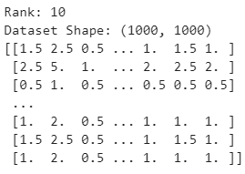

Figure 1: Synthetic Dataset

To run our algorithm on this dataset, we set our matrix density to 20% and recorded our CCR after each iteration. As shown in figure 2, The CCR is indeed changing with iteration number, and the best one occurs at the seventh run. This, to some extent, confirms the validity of the algorithm, at least in theory.

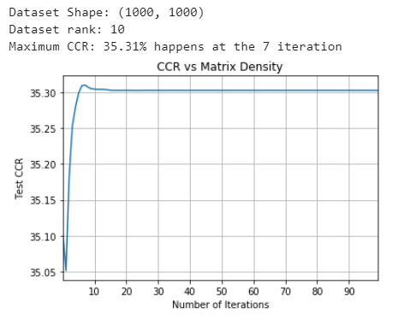

Figure 2: CCR vs Iteration

Next, we wanted to visualize the effect of matrix sparsity on our algorithm discussed above, so we varied the density of our matrix and plotted the CCR while keeping all other variables constant. This is shown in figure 3. From here, it is quite clear that, as expected, the CCR is indeed largely affected by matrix density dropping as low as 30% when at 5% while reaching almost perfect classification starting at 45% density.

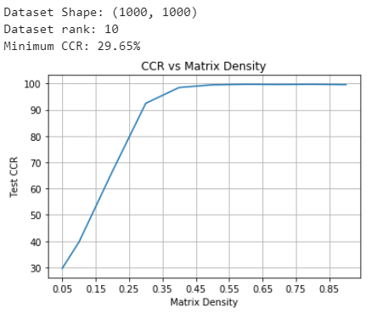

Figure 3: Test CCR vs. Density

**Actual Dataset**

**Second Approach**

**References**

[1] Gude, A. (2019). *9 Must-Have Datasets for Investigating Recommender Systems - KDnuggets*. [online] KDnuggets. Available at: https://www.kdnuggets.com/2016/02/nine-datasets-investigating-recommender-systems.html [Accessed 26 Oct. 2019].

[2] Koren, Y., Bell, R. and Volinsky, C., 2009. Matrix factorization techniques for recommender systems. *Computer*, (8), pp.30-37.

[3] nick becker. (2019). Matrix Factorization for Movie Recommendations in Python. [online] Available at: https://beckernick.github.io/matrix-factorization-recommender/ [Accessed 22 Nov. 2019].